# Logomarca Embrapa CenargenMKTPlace Agricultural Innovation

**FOOD RESEARCH INSTITUTE**

**REPORT ON TRAINER of TRAINERS WORKSHOP HELD AT APESIWA CONFERENCE ROOM, CSIR-FRI, GHANA**

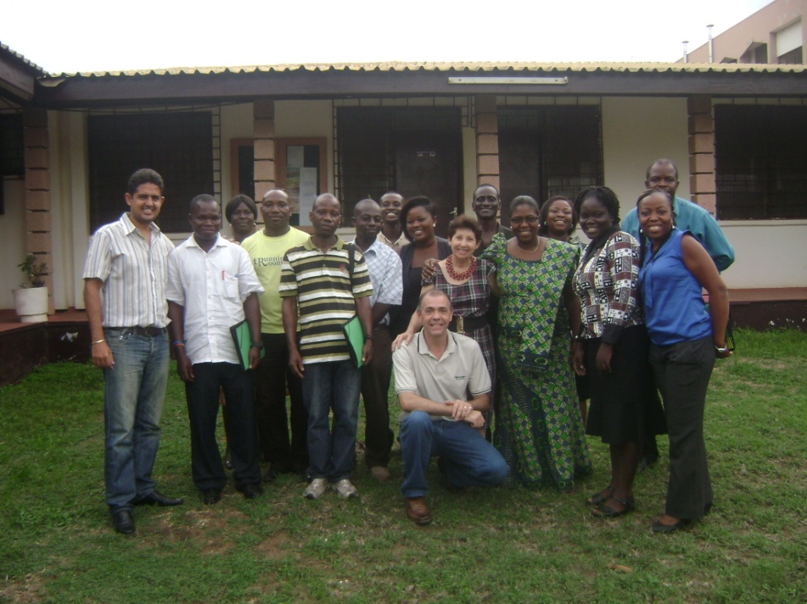

**by**

**Mary Obodai, Deborah Narh, Matilda Dzomeku, Richard Takli and Juanita Prempeh**

**13th-15th MAY, 2013**

# INTRODUCTION

In January, 2012 a project was initiated with the research title “Characterization, conservation and Domestication of indigenous Edible and Medicinal Mushrooms on agricultural residues” (CDEMM). This project is under the sponsorship of Africa–Brazil Agricultural Innovation Marketplace, with FUNARBE as financiers. The CDEMM project is a collaborative project between the Mushroom Unit of the CSIR-FRI and EMBRAPA Genetic Resources and Biotechnology, in Brazil.

As part of this project a three-day intensive trainer-of-trainers workshop on mushroom cultivation using the Juncao Technique was held from Monday 13th to Wednesday, 15th May 2013 at both the Apesiwa Conference Room in CSIR-FRI and the Mushroom Research Facilities at the CSIR-FRI Mushroom Unit. The workshop participants included all members of the CSIR-FRI Mushroom Unit, a member of the CSIR-FRI Nutrition and Socioeconomics Division, three Post Graduate students and a Brazilian who had just completed his PhD thesis (Table 1). The workshop included both lectures and hands-on practical sessions.

# WORKSHOP OBJECTIVES

The overall objective of the workshop was to train members of the Mushroom Unit on mushroom cultivation using the Juncao technique in order to equip them as trainers of mushroom farmers in Ghana as part of the CDEMM project. The specific objectives of the workshop are listed below:

* To inform participants about the diversity of mushrooms available world wide
* To give indebt information about tissue culture and spawn preparation
* To teach participants the steps in mushroom cultivation using the Juncao technique
* To demonstrate appropriate methods and techniques involved in the production of high quality fresh mushrooms.

# WORKSHOP CONTENT

The content of the workshop is detailed in the programme attached.

Ten lectures on Introduction to mushrooms, formulation and preparation of culture medium, mushroom cultivation by Juncao technique, cultivation of *Pleurotus* spp., etc. were delivered by Drs Arailde Urben Fontes and Edison de Souza during the period. These lectures were interspersed with practical aspects which gave the participants a practical feel of the information given during the lectures.

# DETAILS OF DAILY ACTIVITIES

Details of the activities held daily are summarized in the ensuing paragraphs. A prayer was said to begin each day’s activities by a participant upon request. Each participant was asked each day to inform the class about a lesson learnt from the previous day’s lectures and/or practicals.

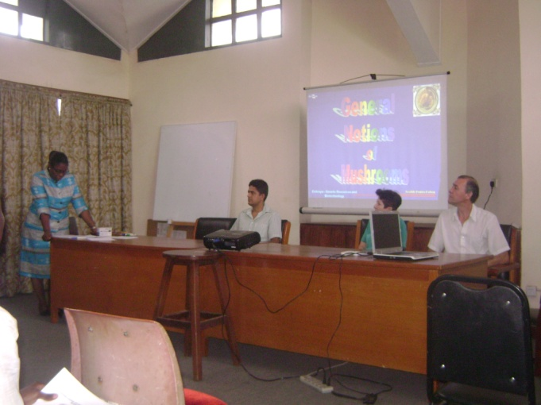

**Brazillian partners being introduced to participants by Unit Head**

**DAY 1:**

After the arrival of guests and participants and the distribution of the course materials, there was a brief welcome address by the Head of Unit. An opening prayer was said after which each participant introduced him/herself to the group and Dr. Obodai introduced the three Brazilian partners in the name of Dr. Arailde Fontes Urben, Dr. Edison de Souza and Dr Vinicius de Figueirêdo to the house to familiarize participants and the resource persons. A group picture was taken at the end of the opening ceremony. The first lecture delivered by Dr. Urben on the General notions of mushrooms preceded a 15 min coffee break. This was followed by a second lecture given by Dr. de Souza on the Formulation and preparation of culture medium. Both resource persons jointly gave practical sessions involving the formulation, preparation and inoculation of culture medium and spawns following a 1hr lunch break. The day ended with tissue culture preparation in the newly created Research Lab of the Mushroom Unit.

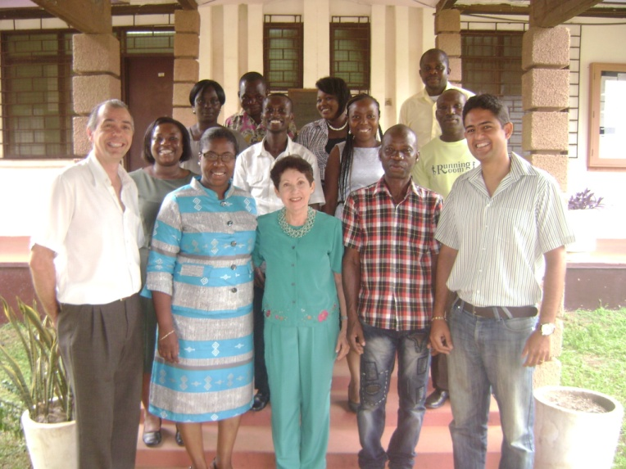

**Group picture at the end of the opening ceremony**

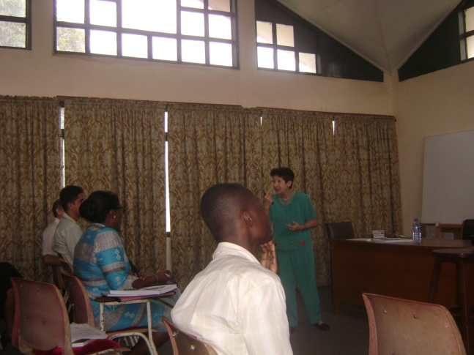

**Dr Fontes Urben during her presentation**

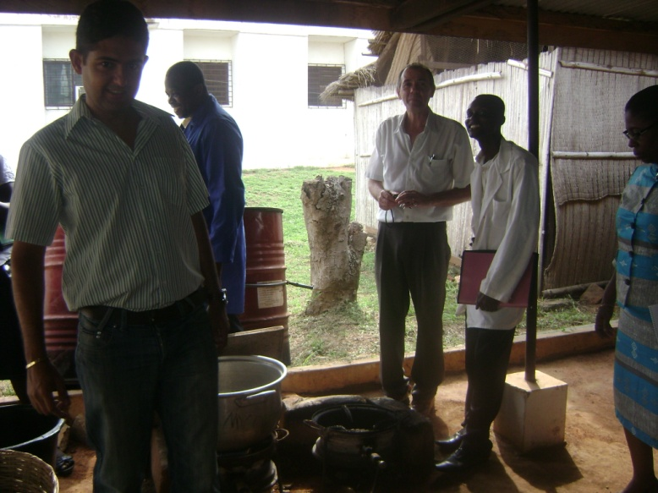

**Participants and Resource person during practical session**

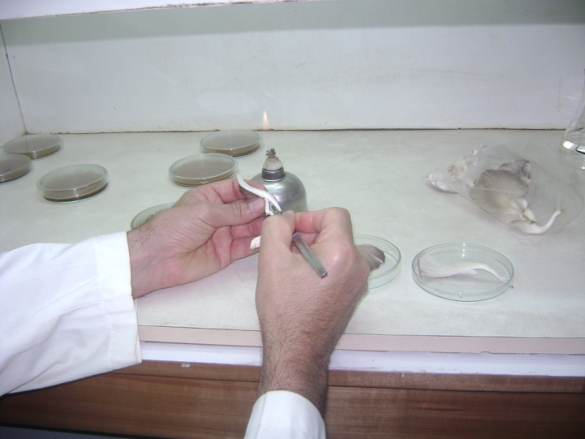

**Resource person during tissue culture preparation**

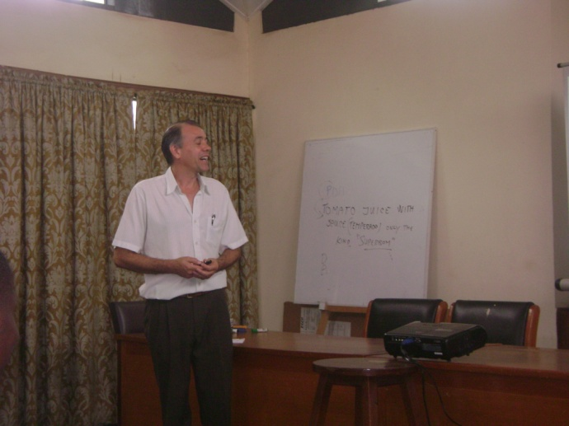

**Dr de Souza during his presentation**

**DAY 2**

The day started with the practical training in the morning followed by the lectures in the afternoon due to some technical hitches with the LCD. This arrangement went well though it was not the preferred trend. The practical session included substrate formulation using chopped and dried elephant grass, rice bran and quick lime and bagging using the Juncao technique in large heat-resistant polypropylene bags. Bag sterilization was done for 3 hrs in the autoclave in the Mushroom Unit during the lunch break and the classroom lectures. Lectures given were on the topics, “Mushroom cultivation by Juncao technique” and “Cultivation of *Pleurotus* spp”.

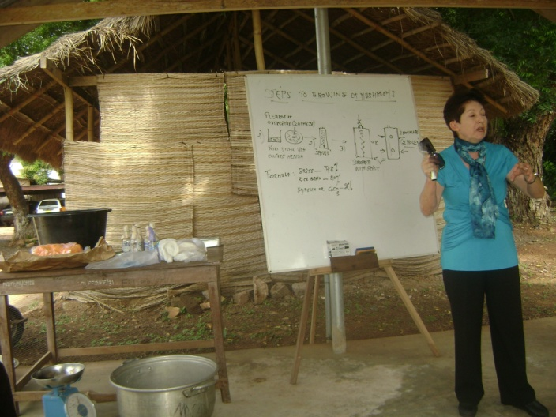

**Resource person during practical session**

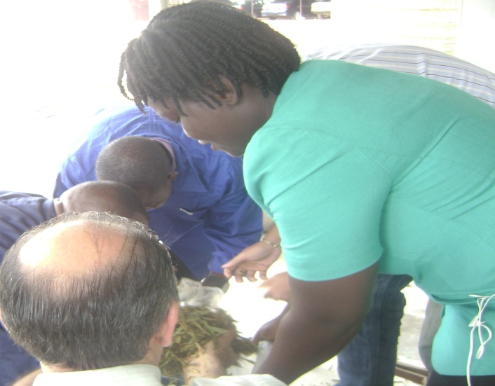

**Participants during practical session**

**DAY 3**

Lectures given on the last day of the workshop included “Cultivation of *Lentinula edodes*, *Agaricus blazei* and *Ganoderma lucidum*” and “Functional mushrooms and their importance in human health”. The lectures were intersperced with a coffee break and a lunch break, during which participants interacted. Other members of staff were invited to listen to the lecture on Functional mushrooms and their importance in human health given by Dr. Urben. Members of staff could not attend due to the timing of the lecture. Dr Obodai gave a short address at the end of the final lecture followed by a vote of thanks given by Ms. Deborah Narh. A group photograph was then taken. Participants were promised copies of the PowerPoint presentations to end the classroom activities. A final activity held was the inoculation of the sterilized compost bags.

**CONCLUSION**

A total of 15 participants were trained in the use of different grasses in the cultivation of various species of mushrooms. The lectures were interesting and the resource persons were very knowledgeable in their disciplines. All the participants were appreciative of the contents of the workshop and were determined to practice what they had learnt.

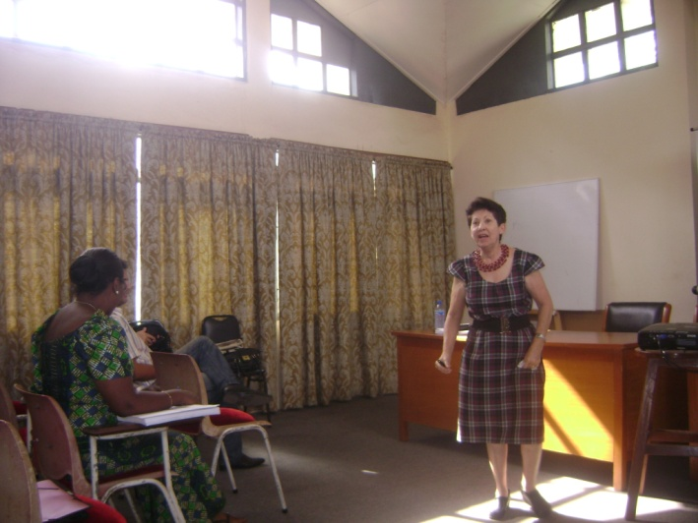

**Resource person during the lecture period**

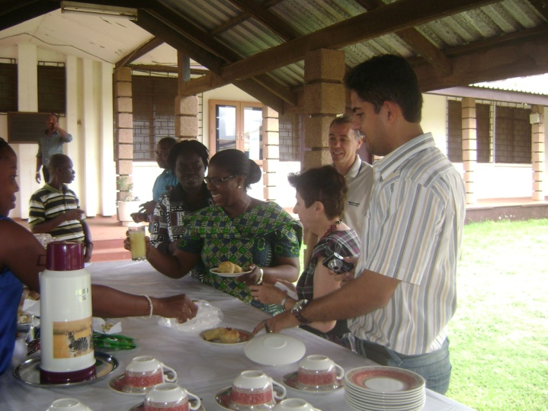

**Participants during coffee break**

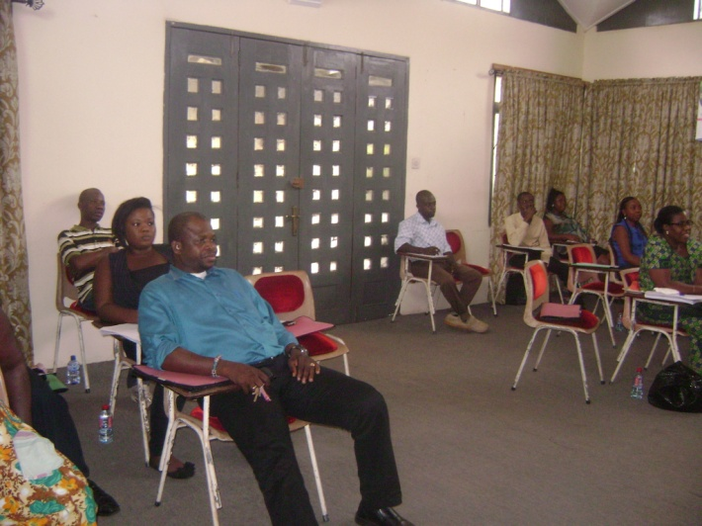

**Participants during lectures**

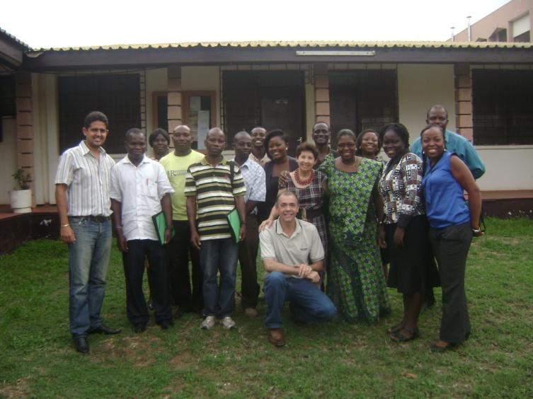

**Group picture after the training workshop**

TABLE : LIST OF PARTICIPANTS OF THE TRAINER-OF-TRAINERS WORKSHOP (CDEMM PROJECT)

|  |  |
| --- | --- |
| **Name** | **Designation/Institution** |
| Dr. (Mrs.) Mary Obodai  Ms. Matilda Dzomeku  Ms. Deborah L. Narh  Mr. Richard K. Takli  Mrs. Lynda Hagan  Ms. Juanita Prempeh  Dr Vinicius de Figueirêdo  Mr. Michael Wiafe-Kwagyn  Mr. Nii Korley Kortei  Ms. Esther Harris Quaicoo  Mr. Godson Agbeley  Mrs. Rose Agorkor  Mr. Ababase Akanzinam  Mr. Moses Mensah | Head of Mushroom Unit/ CSIR-FRI  Research Scientist/ CSIR-FRI  Research Scientist/ CSIR-FRI  Senior Technologist/ CSIR-FRI  Research Scientist/ CSIR-FRI  National Service Person/ CSIR-FRI  Brazil  PhD student/ University of Ghana  PhD student/ Graduate School of Nuclear and Allied Sciences  MPhil student/ University of Ghana  Technical Assistant / CSIR-FRI  Technical Assistant / CSIR-FRI  Technical Assistant / CSIR-FRI  Technical Assistant / CSIR-FRI |

**PROGRAMME**

**TRAINING COURSE ON EDIBLE AND MEDICINAL MUSHROOMS**

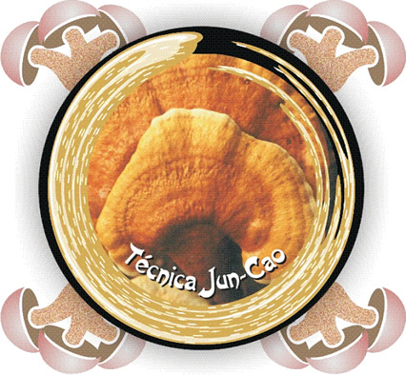

**Period: May, 13 to 15, 2013**

**Technical coordination:**

**Arailde Fontes Urben**

**Mary Obodai**

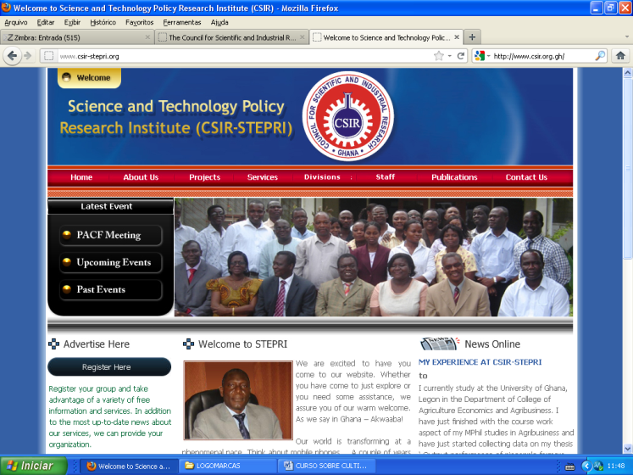

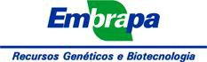

**Ghana - Africa**

**2013**

**Day 1 - Monday (05/13/2013)**

**Morning (lectures)**

|  |  |
| --- | --- |
| **08:00 – 08:15** | **Distribution of course material** |
| **08:15 – 08:30** | **Opening the training course** |
| **08:30 – 08:45** | **Presentation of students** |
| **08:45 – 09:30** | **General notions of mushrooms - Dr. Arailde Fontes Urben** |
| **09:30 – 10:00** | **Coffee break** |
| **10:00 – 11:30** | **Formulation and preparation of culture medium, "seeds" and cultivation substrate - Prof. Edison de Souza** |
| **11:30 – 13:30** | **Lunch** |

**Afternoon (practical classes)**

|  |  |
| --- | --- |
| **13:30 – 15:00** | **Formulation, preparation and inoculation of culture medium - Prof. Edison de Souza and Dr. Arailde Fontes Urben** |
| **15:00 – 15:30** | **Coffee break** |
| **15:30 – 17:30** | **Formulation, preparation and inoculation of "seeds" - Prof. Edison de Souza and Dr. Arailde Fontes Urben** |

**Day 2 - Tuesday (5/14/2013)**

**Morning (lectures)**

|  |  |
| --- | --- |
| **08:00 – 09:30** | **Mushroom cultivation by Juncao technique - Dr. Arailde Fontes Urben** |
| **09:30 – 10:00** | **Coffee break** |
| **10:00 – 11:30** | **Cultivation of *Pleurotus* spp. - Prof. Edison de Souza** |
| **11:30 – 13:30** | **Lunch** |

**Afternoon (practical classes)**

|  |  |
| --- | --- |
| **13:30 – 15:00** | **Formulation, preparation and inoculation of culture substrates – (Part I) - Prof. Edison de Souza and Dr. Arailde Fontes Urben** |
| **15:00 – 15:30** | **Coffee break** |
| **15:30 – 17:30** | **Formulation, preparation and inoculation of culture substrates - (Part I) - Prof. Edison de Souza and Dr. Arailde Fontes Urben** |

**Day 3 - Wednesday (15/05/2013)**

**Morning (lectures)**

|  |  |
| --- | --- |
| **08:00 – 09:15** | **Cultivation of *Lentinula edodes* - Dr. Arailde Fontes Urben** |
| **09:15 – 10:30** | **Cultivation of *Agaricus blazei* - Prof. Edison de Souza** |
| **10:30 – 10:45** | **Coffee break** |
| **10:45 – 12:00** | **Cultivation of *Ganoderma lucidum* - Dr. Arailde Fontes Urben** |
| **12:00 – 13:30** | **Lunch** |

**Afternoon (lectures)**

|  |  |
| --- | --- |
| **13:30 – 14:30** | **Diseases and pests and their control - Dr. Arailde Fontes Urben** |
| **14:30 – 15:00** | **Coffee break** |
| **15:00 – 16:30** | **E** **Economi Economical Aspects of Fungiculture: Processing and marketing - Prof. Edison de Souza** |
| **16:30 – 17:30** | **Functional Mushrooms and their importance in Human Health - Dr. Arailde Fontes Urben** |
| **17:30 – 18:00** | **Closing** |